**Great Ideas to Enjoy a Refreshing Green Workspace**

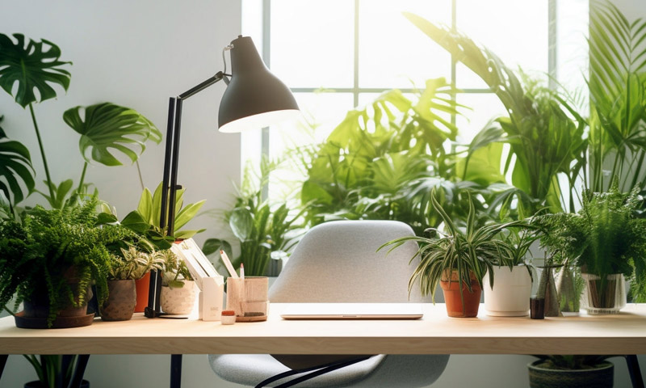

In modern life, the office has become the place where we spend the majority of our day. Therefore, creating a comfortable and friendly working environment not only benefits our health and mental well-being but also improves work performance. An effective way to make the office lively and refreshing is by incorporating plants. In this article, let’s join **Green Grover** in exploring the benefits of growing green plants in the office, along with some creative ideas and popular types of plants to decorate your workspace.

**1. Benefits of Growing Green Plants in the Office**

Having plants in the office not only serves as a decorative highlight but also provides numerous other benefits. First, ornamental plants improve air quality by absorbing harmful toxins and releasing oxygen through photosynthesis. This promotes better health and mental clarity for employees, reducing stress and fatigue. Moreover, plants can trap dust and lower noise levels in the work environment.



**2. Ideas for Decorating the Office with Green Plants**

**Reception Area**

The reception area is where clients and partners are welcomed, making it essential to create a good first impression. Positioning large plants like ferns or bamboo in this space can create a striking effect and a welcoming atmosphere. These plants bring vitality and warmth to the space.

**Workspace Corners**

If you have a personal workspace corner, use it to craft a comfortable and creative environment. Place small plants like lucky bamboo or lotus plants in this corner to add a touch of freshness and tranquility. These plants not only make the space more enjoyable but also contribute to a positive mood and improved concentration.

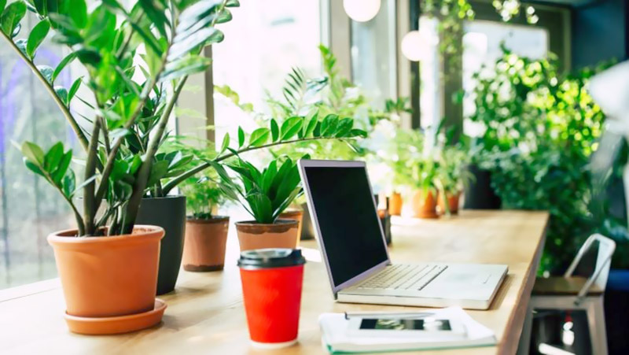

**On the Desk**

Adding a small plant to your desk can create a focal point and bring a sense of freshness to your immediate workspace. Popular choices include snake plants or small hanging plants like succulents. Position them near a window to provide sufficient natural light for easy care.

**In the Meeting Room**

Including a large plant or several small plants in the meeting room can create a relaxing atmosphere for discussions. Green plants provide a calming effect and reduce stress for everyone involved. Plants like pine or melaleuca, which produce high levels of oxygen, are ideal choices for this space. To avoid obstructing views, place the plants in a corner of the meeting room to create a natural and pleasant environment.



**3. Popular Plants for Office Decoration**

**Money Tree**

The Money Tree is one of the most loved and commonly chosen office plants. In Feng Shui, it is regarded as one of the luckiest plants, bringing prosperity and fortune to its owner.

Additionally, the Money Tree thrives in low-light environments without direct sunlight, making it perfect for offices. Small, charming pots can be placed on desks, enhancing aesthetics and bringing a vibrant touch of nature to the room, while also holding symbolic Feng Shui meanings.

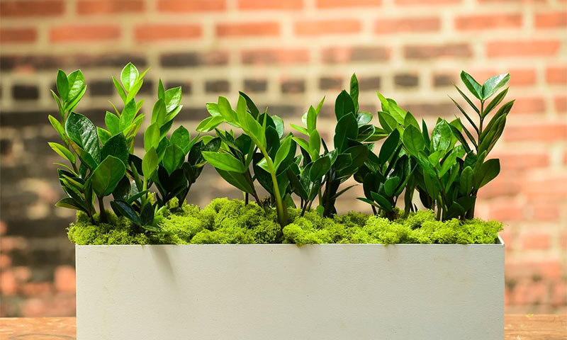

**Snake Plant**

The Snake Plant, known for its resilience even in low-light conditions, symbolizes strength and perseverance in the face of challenges.

Widely recognized for its air-purifying abilities, the Snake Plant absorbs toxins and is even used in traditional medicine. From a Feng Shui perspective, this plant is believed to ward off negative energy and bring luck, prosperity, and wealth.

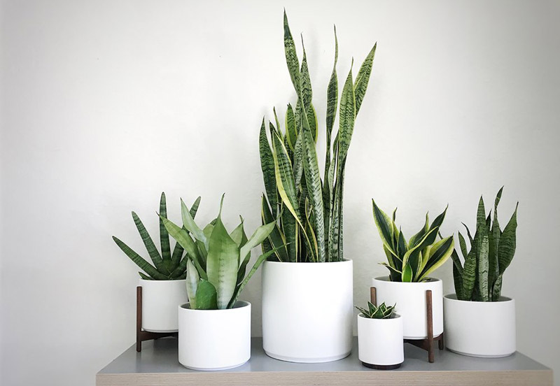

**Lucky Plant**

As its name suggests, the Lucky Plant symbolizes good fortune and prosperity for its owner. This plant is highly suitable for home offices or company workspaces. Beyond its Feng Shui meaning, the Lucky Plant provides relaxation and peace of mind, inspiring creativity and accurate decision-making in work and study.

This plant thrives in soft light and should avoid direct sunlight. You can expose it to mild sunlight for 15 to 30 minutes daily for optimal growth.

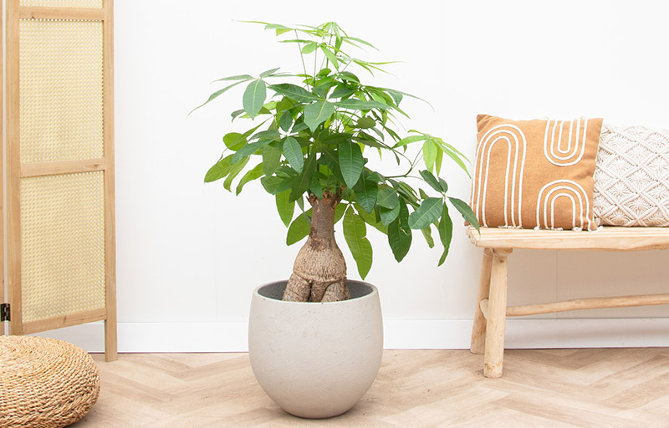

**Lucky Bamboo**

If you're looking for a Feng Shui plant that brings health, prosperity, and good fortune, Lucky Bamboo is an excellent choice. Placing a pot of Lucky Bamboo on your desk can help attract luck in wealth, career advancement, and overall well-being. Since this plant dislikes strong direct sunlight, keep it in shaded areas and water it once or twice a week.

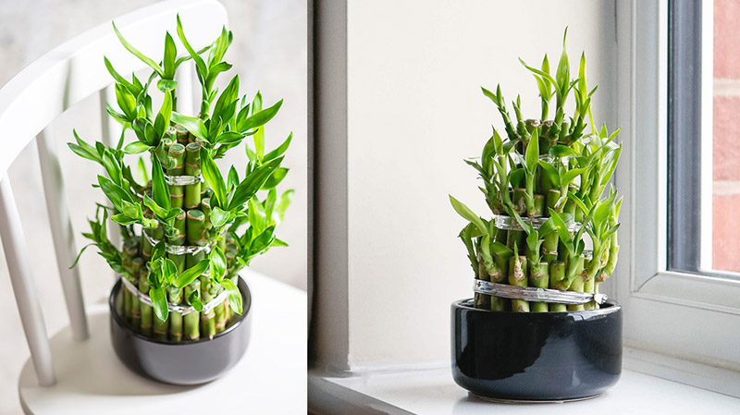

**Schefflera**

Schefflera, also known as the Umbrella Plant, is a low-maintenance plant that adapts easily to different environments, making it a popular choice for indoor decoration.

Its evergreen leaves provide year-round freshness and inspiration, adding vitality to the office space. In Feng Shui, the Umbrella Plant is a symbol of encouragement and unity among team members.

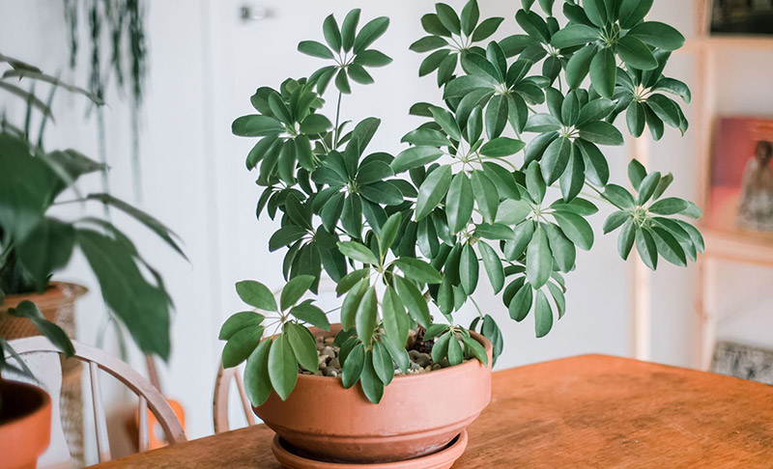

**Pennywort Plant**

Decorating your desk with a small Pennywort plant can help relieve work stress and increase focus. This plant not only keeps the air fresh but also wards off negative energy, bringing good luck and fortune.

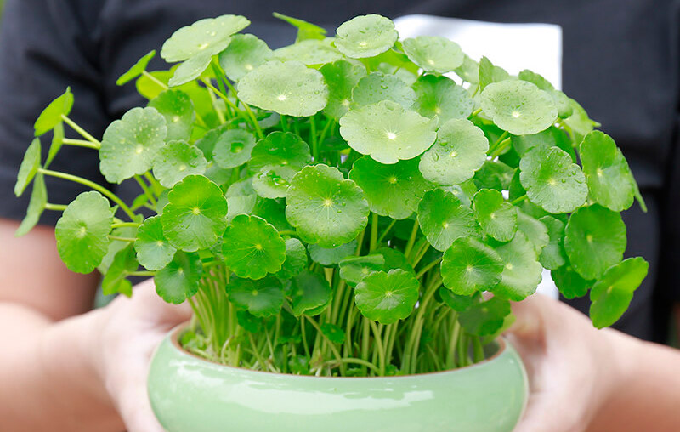

**Golden Pothos**

The Golden Pothos is a familiar and versatile plant, ideal for both decoration and air purification. Renowned for its ability to absorb toxins, it enhances air quality effectively. Additionally, this plant carries Feng Shui significance, symbolizing luck and smooth progress in academics and career pursuits.

Golden Pothos can grow in soil or water, making it adaptable for various setups. If grown in soil, you can hang it high to let its trailing leaves cascade beautifully. Since it thrives in shaded conditions and only tolerates soft light, choose its location accordingly.

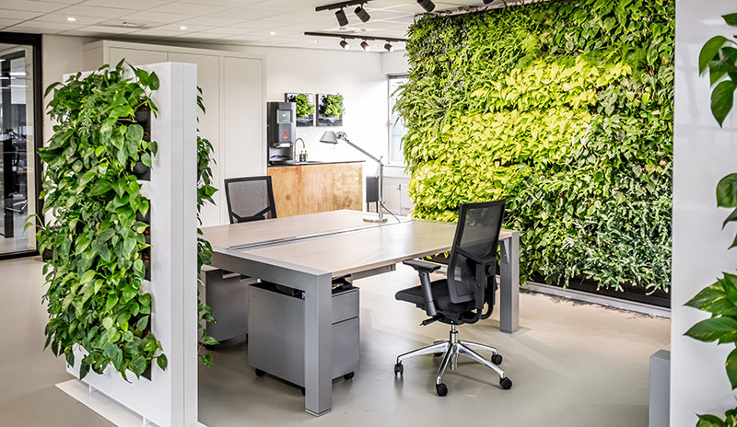

**Conclusion**

Incorporating plants in the office is an effective way to create a comfortable and refreshing workspace. Green plants not only provide health and mental benefits for employees but also add a decorative touch, bringing life to the workspace.